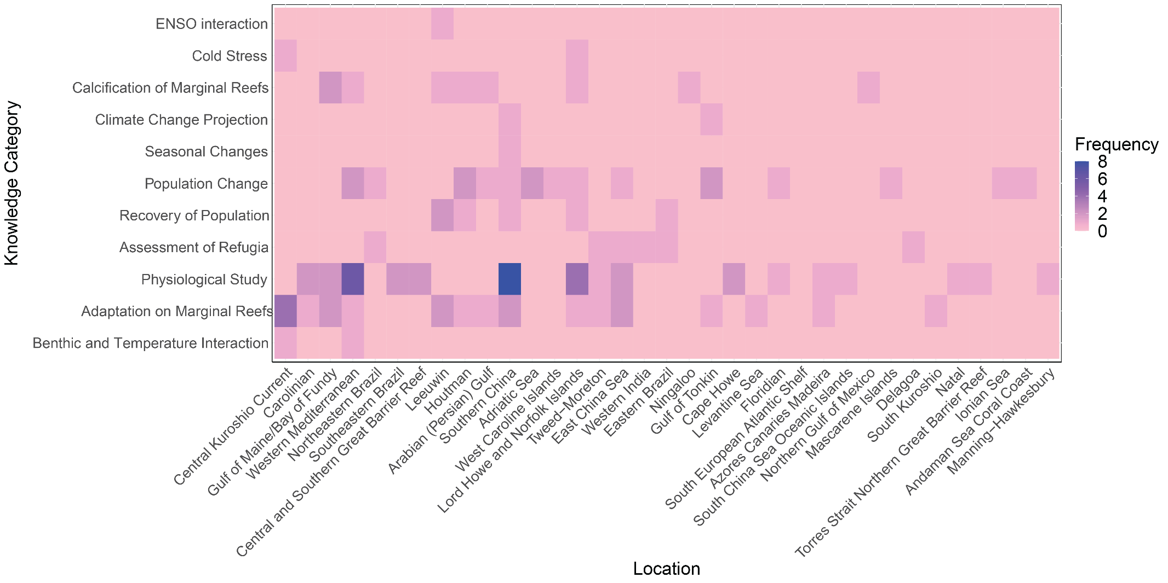

Figure 15 Heatmap of the knowledge category with respect to ecoregions from studies included in this systematic map.